Conversation Quality Evaluation – Documentation

1. Overview

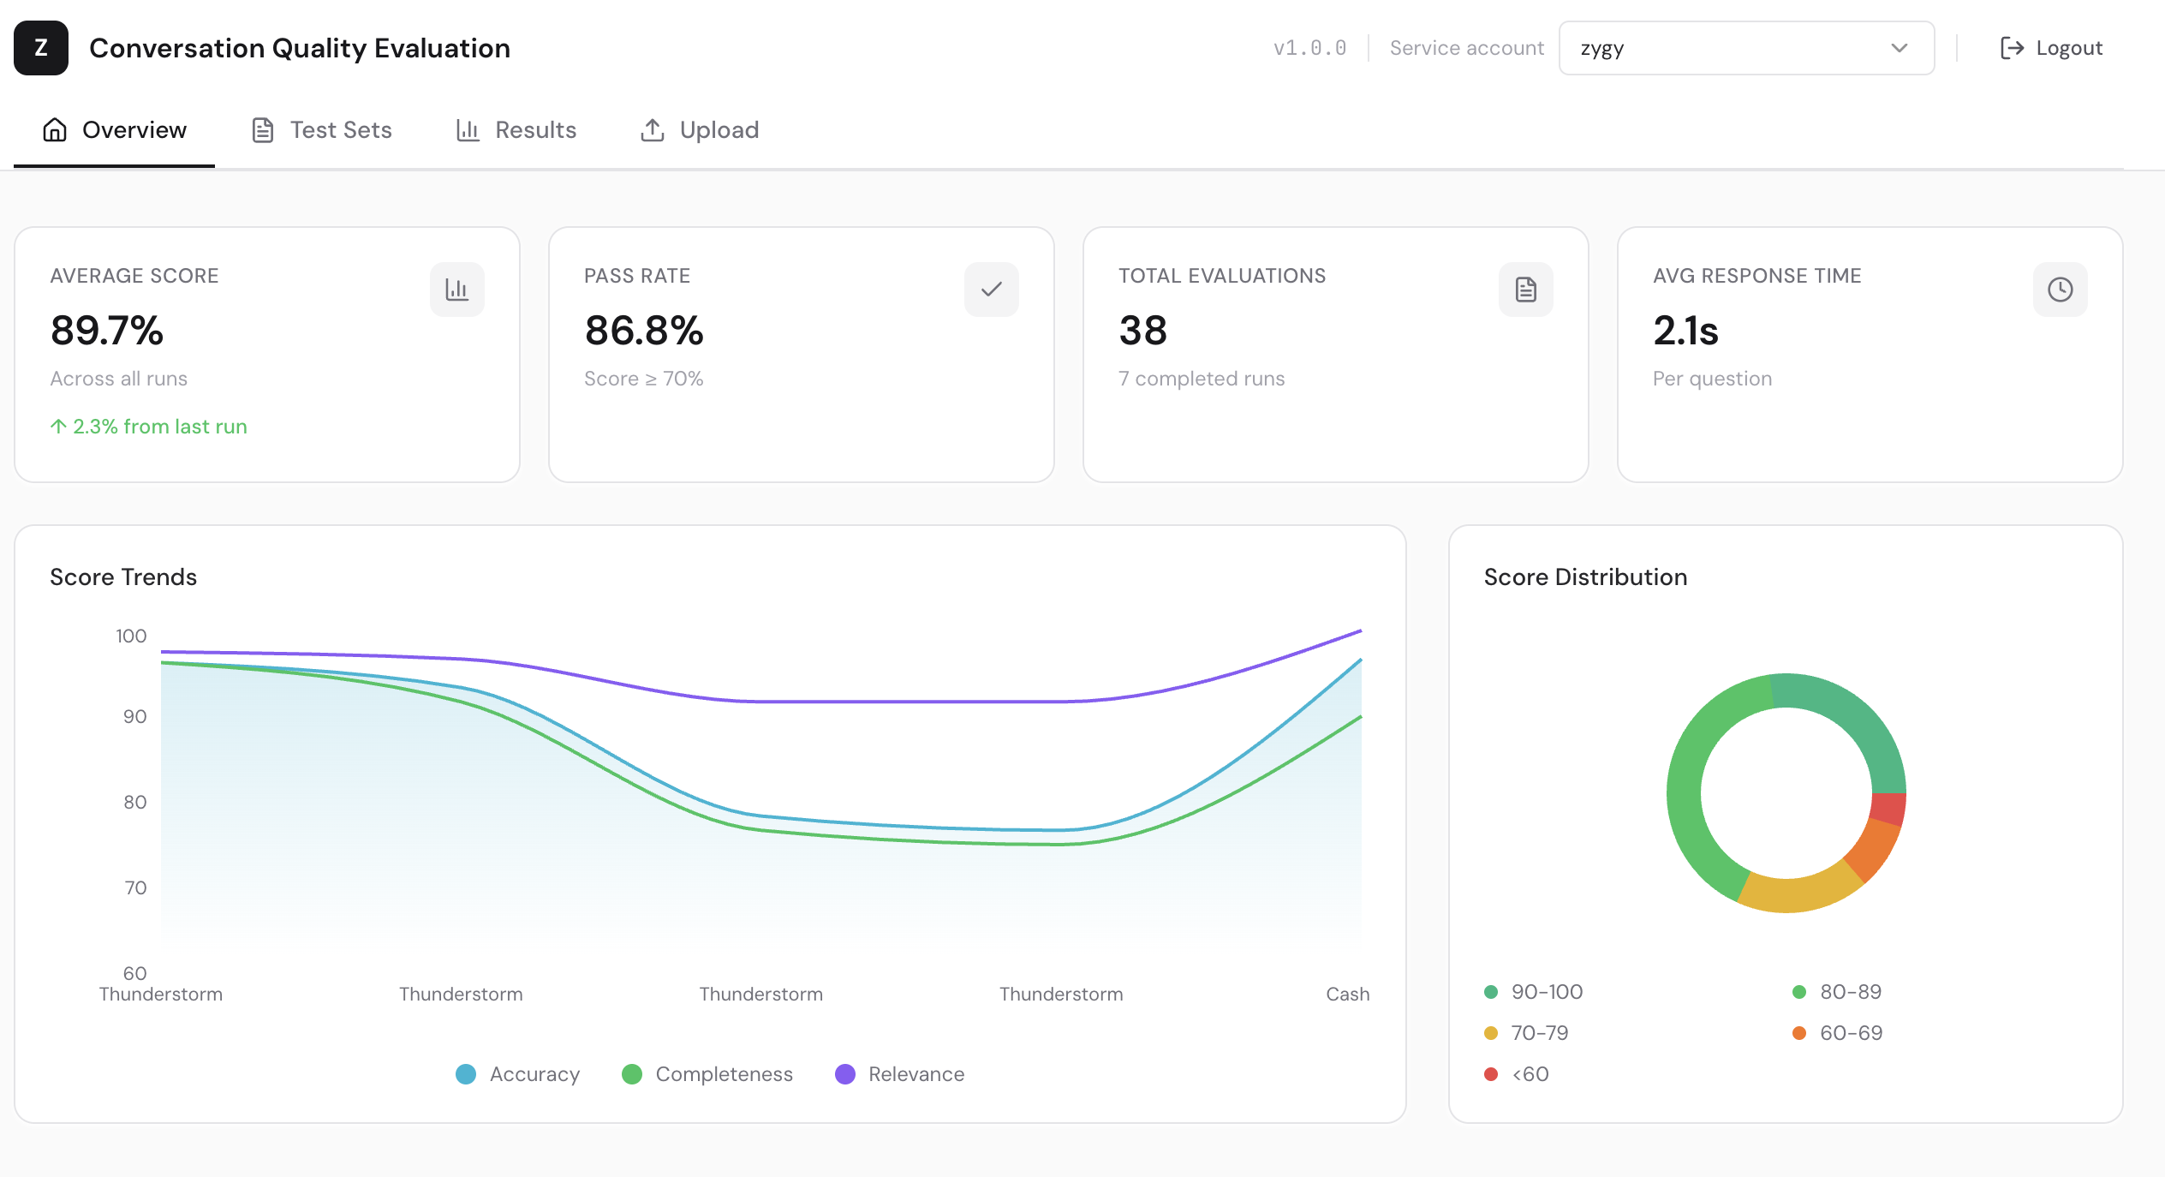
The Conversation Quality Evaluation page is used to evaluate the performance and quality of responses generated by a Retrieval-Augmented Generation (RAG) system. The evaluation is performed using a CSV test dataset that contains predefined questions and ground truth answers. The system compares the generated responses against the ground truth answers and uses a Large Language Model (LLM) to score the quality of each response across several evaluation dimensions.

2. Test Set Structure
The evaluation process begins with uploading a CSV test set. Each row in the CSV represents one evaluation case.
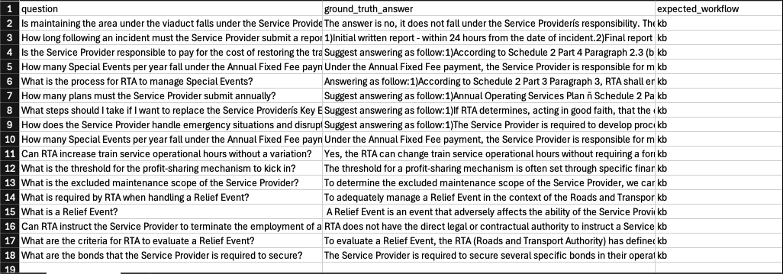
Figure 1 Example csv data

2.1 Required Fields
The following fields must be present in the CSV file:
- question – The user query that will be sent to the system.
- ground_truth_answer – The expected correct answer used as the evaluation reference.

2.2 Optional Fields
The following fields are optional and can provide additional evaluation context:
- expected_workflow – Expected workflow or reasoning path. (kb or excel)
- expected_documents – A comma-separated list of expected document IDs (docIds) that should be retrieved.
- category – A label used to group or classify the question.

3. Uploading the Test Set
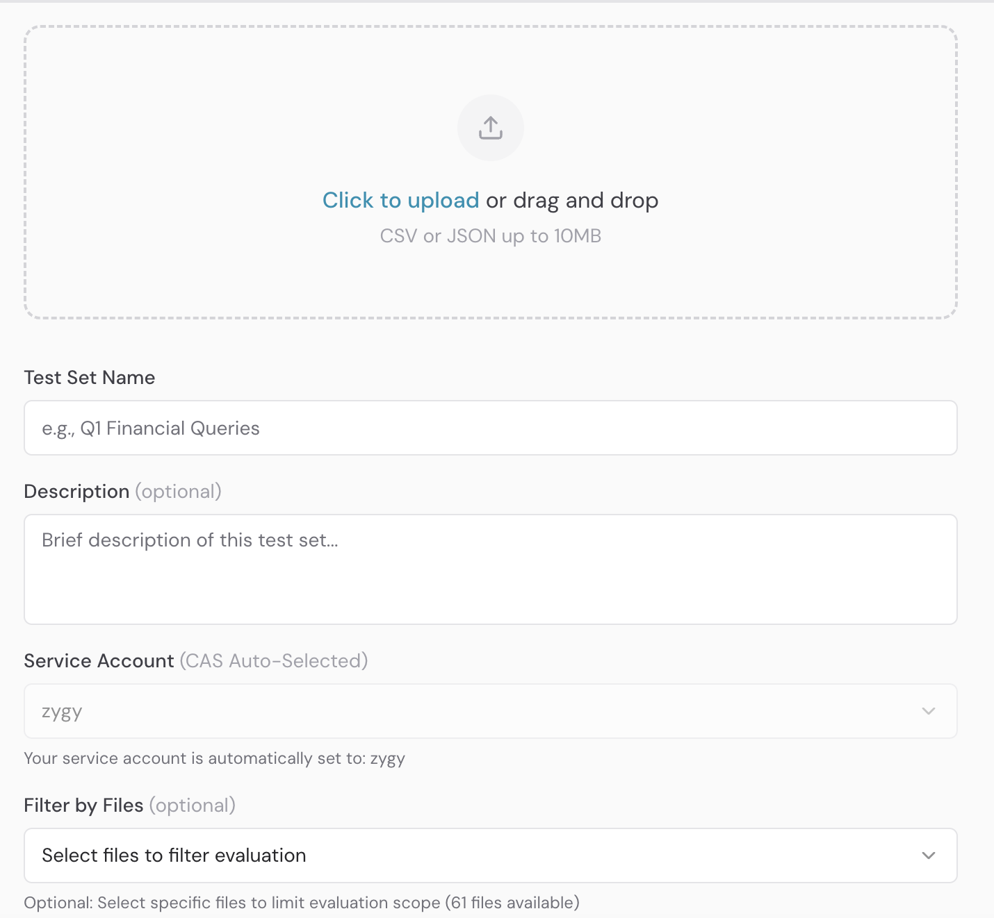
After preparing the CSV file with the required structure, the file can be uploaded into the system. You can change the test set name accordingly. Description and filter by files are optional field that you can fill up.
For more controlled evaluation results, it is recommended to use Filter by Files so that the retrieval process is limited to the specified documents. Once uploaded, the dataset will appear on the Test Sets page where it can be managed.

4. Managing Test Sets
The Test Sets page displays all uploaded evaluation datasets. From this page, users can:
- View uploaded test sets.
- Edit test set values if adjustments are required. (Question button)
- Start the evaluation process. (Run Button)

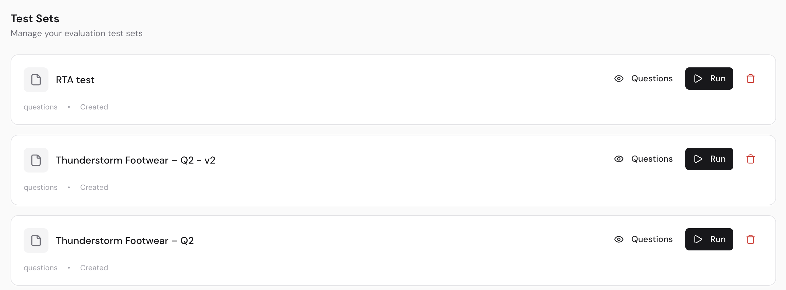

5. Running an Evaluation
An evaluation can be triggered directly from the Test Sets page. When the evaluation is started, the system processes each question in the test set and generates answers using the configured RAG pipeline. The generated responses are then compared against the ground truth answers.

6. Results Page
After the evaluation run is initiated, the results are displayed on the Results page. This page provides an overview of the evaluation execution.
The results page displays the following information:
- Status – Current execution state of the evaluation.
- Progress – Percentage of completion.
- Score – Overall aggregated score of the test set.
- Pass Rate – Percentage of test cases that meet the passing criteria.

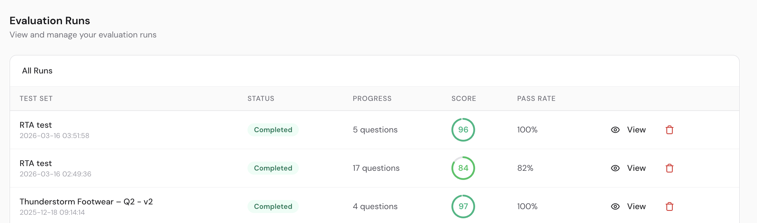

7. Detailed Result View
By clicking the Detail View option, users can inspect the results for each individual question in the test set.
Each evaluation entry includes the following metrics:
- Score – Overall score for the response.
- Accuracy – Factual correctness compared to the ground truth.
- Number of Chunks – Number of retrieved document chunks used for the answer.
- Response Time – Time taken to generate the answer.

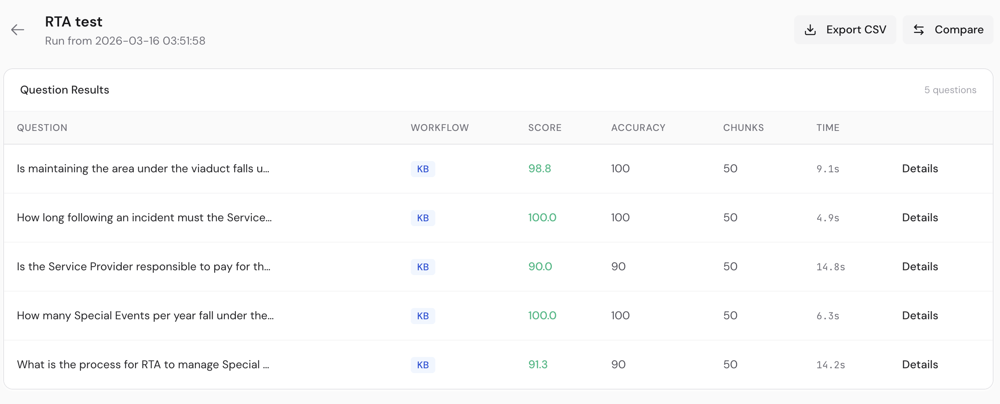

8. Scoring Methodology
Each generated response is evaluated by an LLM using four scoring dimensions. Each dimension is rated on a scale from 0 to 100.

8.1 Accuracy
Measures factual correctness compared to the ground truth.
90–100: Completely accurate, all facts correct
70–89: Mostly accurate with minor factual deviations
50–69: Partially accurate, some important facts wrong
0–49: Largely inaccurate or factually wrong

8.2 Completeness
Measures how well the response covers all key points.
90–100: Covers all key points comprehensively
70–89: Covers most key points, minor omissions
50–69: Covers some key points, missing important information
0–49: Missing most key points or essential information

8.3 Relevance
Measures whether the response stays on topic.
90–100: Perfectly focused, no hallucinations or irrelevant details
70–89: Mostly relevant with minor tangents
50–69: Some irrelevant information or mild hallucinations
0–49: Significant hallucinations or off-topic content

8.4 Semantic Similarity
Measures meaning alignment with the ground truth.
90–100: Expresses the same meaning in different words
70–89: Similar meaning with some interpretation differences
50–69: Partial meaning overlap
0–49: Different meaning or contradictory

9. Overall Score Calculation
The overall score is calculated as the average of the four evaluation dimensions: Accuracy, Completeness, Relevance, and Semantic Similarity.
Overall Score = (Accuracy + Completeness + Relevance + Semantic Similarity) / 4

10. Purpose of the Evaluation
The Conversation Quality Evaluation system helps developers and product teams measure the quality and reliability of AI-generated responses. It enables continuous benchmarking of RAG system performance and provides insight into areas where the system may require improvement, such as retrieval accuracy, response completeness, or hallucination reduction.

